./

Learning Report – Automotive Systems and Overview



|  |  |  |  |  |  |
| --- | --- | --- | --- | --- | --- |
| **Ver.Rel. No.** | **Release Date** | **Prepared. By** | **Reviewed By** | **To be approved By** | **Remarks/Revision Details** |
| 1 | 20.03.2021 | Sourav |  |  |  |
| 2 | 20.03.2021 | Santosh |  |  |  |
| 3 | 20.03.2021 | Ravi |  |  |  |
| 4 | 20.03.2021 | Sushma |  |  |  |
| 5 | 20.03.2021 | Rajendra H |  |  |  |

**Document History**

Table of Contents

Table of Figures 3

Table of Tables 3

1.INTRODUCTION: 4

2.Research and Literary Survey 7

2.1 Airbag: 7

2.2 Wiper Control System: 12

2.3 Internal Lightning of a car 15

2.4 Seat Belt Module: 21

2.5 HVAC Module 25

2.6 FEATURE: 34

2.7 SWOT: 37

3.REQUIREMENTS: 40

3.1 HIGH LEVEL REQUIREMENTS: 40

3.2 LOW LEVEL REQUIREMENTS: 40

4.TEST PLAN: 42

4.1High Level Test Plan: 42

4.2 Low Level Test Plan: 43

5.Design and Implementation: 46

6.References: 46

## Table of Figures

Figure 1 ACTIVITY DIAGRAM (HIGH LEVEL) ………………………………………………………………………………………………..….09

Figure 2 USE CASE DIAGRAM (LOW LEVEL)…………………………………………………………………………………………………….10

Figure 3 CLASS DIAGRAM (LOW LEVEL) …………………………………………………………………………………………………………11

Figure 4 TEST PALN………………………………………………………………………………………………………………………………………..12

Figure 5 GIT 16

Figure 6 GIT ISSUES 17

Figure 7 GIT COMMITS 1 18

Figure 8 GIT COMMIT 2 19

## Table of Tables

Table 3 REQUIREMENTS (HLR AND LLR) 06

Table 4 HIGH LEVEL TEST PLAN 15

Table 5 LOW LEVEL TEST PLAN 16

# 1.INTRODUCTION:

This document work towards Safety and some body control features and safety system which is present in modern-day cars.

This document gives detailed information about the following systems:

1. Airbag control system
2. Wiper Control system
3. Internal lightning of a car
4. Seatbelt control system
5. HVAC system.

The purpose of the air bag is to provide a cushion between the occupants and the vehicle’s interior. For air bags to be effective they must be fully inflated in a short amount of time, before the occupants contacted them. However, this rapid inflation can potentially cause fatal injuries to certain people if they are in contact with the air bag during its inflation. Therefore, air bags must have a control system that can recognize a crash correctly, and early enough for the air bags to inflate safely.

A windscreen wiper or windshield wiper is a device used to remove rain, snow, ice, washer fluid, water, and/or debris from a [vehicle's front window](https://en.wikipedia.org/wiki/Windscreen) so the vehicle's operator can better see what's ahead of them. Almost all [motor vehicles](https://en.wikipedia.org/wiki/Motor_vehicle), including [cars](https://en.wikipedia.org/wiki/Car), [trucks](https://en.wikipedia.org/wiki/Truck), [buses](https://en.wikipedia.org/wiki/Bus), [train](https://en.wikipedia.org/wiki/Train) [locomotives](https://en.wikipedia.org/wiki/Locomotive), and [watercraft](https://en.wikipedia.org/wiki/Watercraft) with a [cabin](https://en.wikipedia.org/wiki/Cabin_(ship))—and some [aircraft](https://en.wikipedia.org/wiki/Aircraft)—are equipped with one or more such wipers, which are usually a legal requirement.

Most cars have at least one "dome light" (or "courtesy light") located in or near the ceiling of the passenger compartment, to provide illumination by which to fasten seatbelts and enter or exit the car. These often have an option to switch on when the front (or any) passenger doors are opened. Many vehicles have expanded this feature, causing the overhead interior light to remain on after all doors are closed, allowing passengers to fasten seat belts with added illumination. The extended lighting cycle usually ends when the vehicle's ignition has begun, or a gradual reduction in light emitted after a couple of minutes if the car isn't started, called "theater" lighting. Interior lighting has been added on some vehicles at the bottom edge of the dashboard, which illuminates the floor for front passengers, or underneath the front seats at the rear, to illuminate the floor for rear seat passengers. This type of convenience lighting approach is also sometimes used to illuminate interior or exterior door handles, exterior step running boards, or electric window switches.

The recent steady reduction in the fatality rate has been the result of a combination of a variety of factors including vehicle crash safety, engineering developments.

Seat belt is one of the primary safety features used in vehicle to avoid major injuries to the driver driving the vehicle. Even after the government norm that is wearing of seat belt is mandatory, accidental injuries increase due to negligence of occupants in vehicle of wearing seat belt. If seat belt is not buckled correctly than the chances of accidental injuries increase. To avoid these, different companies found variety of seat belt systems such as passive seat belt system, automatic seat belt system, seat belt warning system and so on. So, in this project we have proposed better seat belt system than the present ones. This system comprises of sensor, micro controller and locking mechanism in wheel and seat belt. In this system vehicle propels only when seat belt and door are locked properly. According to our estimation this system can decrease fatality up to 70- 80% in comparison to present system.

Heating, ventilation and air conditioning (HVAC) is the technology for indoor and automotive ambient comfort. HVAC facilitates in managing the pleasant climate inside the cabin by controlling the degree of hotness/coolness.

# 2.Research and Literary Survey

This document brings about a detailed work in some body control and safety application present in the modern-day cars. The modern-day car can be divided into few parts as given below:

1. Chassis
2. Powertrain
3. Body

This segment shows the detailed research work in the body control module and safety feature. This segment is divided into several parts like the input required to build the system; the logic or the workflow; the different modes of output.

As safety in a car gets the most priority so we start the discussion with the safety feature that is described in this document.

## 2.1 Airbag:

2.1.1 Input or the Sensors:

1. Crash sensor: Early air bag deployment systems in older vehicles utilized mechanical sensors for crash detection. Early mechanical sensors, such as the “rolamite” by Sandia National Laboratories, relied on a metallic sphere that was stabilized at a standby position by a spring or a magnet.

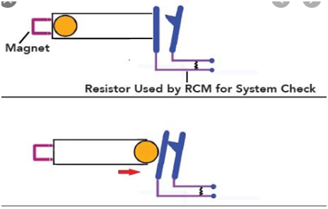

Figure 1. Ball and tube type sensor

1. MEMS Sensor: New MEMS crash sensors measure acceleration with an accelerometer that sends a continuous stream of data to the air bag control module. Accelerometers are typically piezoelectric or variable capacitance sensors. The most common MEMS accelerometer in use today is the ADXL-50 by Analog Devices. As an anchored mass moves relative to the sensor’s body due to acceleration, a plate attached to the anchored mass moves closer to a stationary plate. The change in distance between the plates affects the capacitance of the sensor, or the ability to hold an electrical charge. This change in capacitance is easily measured and is then converted to a change in voltage. The voltage change is directly correlated to force due to acceleration, and the readings are interpreted as acceleration by the air bag control module. Using an algorithm, the control module can determine if air bag deployment is necessary based on the pattern of the acceleration pulses over time.

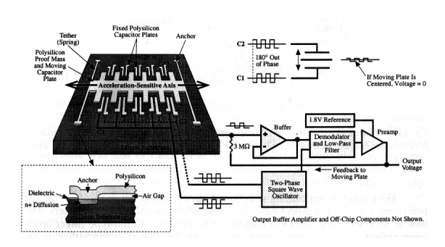

Figure 2. MEMS Crash Sensor

One of the pioneers in fabricating accelerometers in integrated circuit form is Analog Devices, which produces the ADXL50 accelerometer. The ADXL50 provides an output voltage that varies proportionally with the amount of acceleration experienced along its sensitive axis. It has an input range of -50g to +50g, with a sensitivity of approximately 1 V per 50 g. Thus, a 50-g acceleration would either decrease or increase the output at 0 g by 1V, depending on the direction of the acceleration. Since the ADXL50 is calibrated to output 1.8V when there is no acceleration, the output would either 0.8 V or 2.8 V at 50 g, again depending on the acceleration's direction.

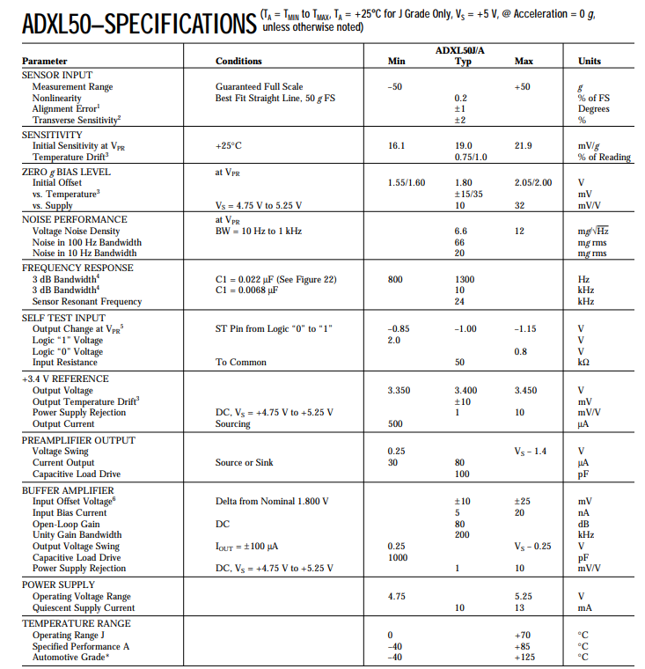

Figure 3. Datasheet of ADXL50

2.1.2 Algorithm

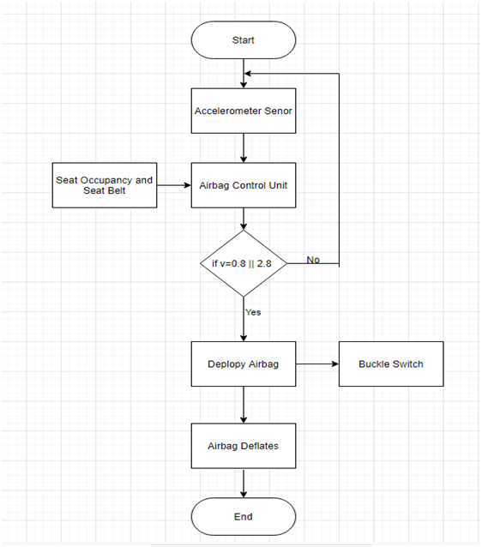

Figure 4. Flow Chart of Airbag System

2.1.3 Output

* Squib Driver: To fire the gas generators and inflate Airbag.
* Loosen the Buckle switches at Seatbelt

## 2.2 Wiper Control System:

2.2.1 Input or the Sensor:

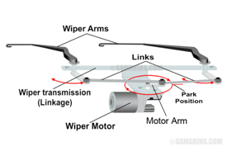

2.2.2 Algorithm

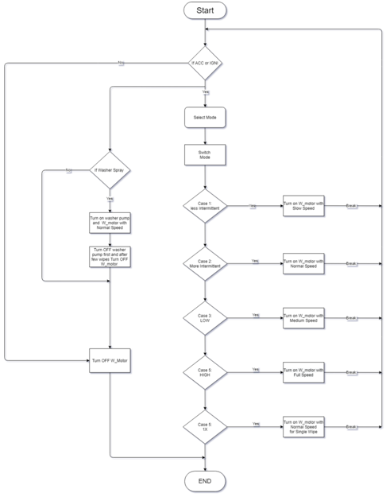

2.2.3 Outputs:

* Wiper Motor Control according to User inputs.
* Water Pump Control.

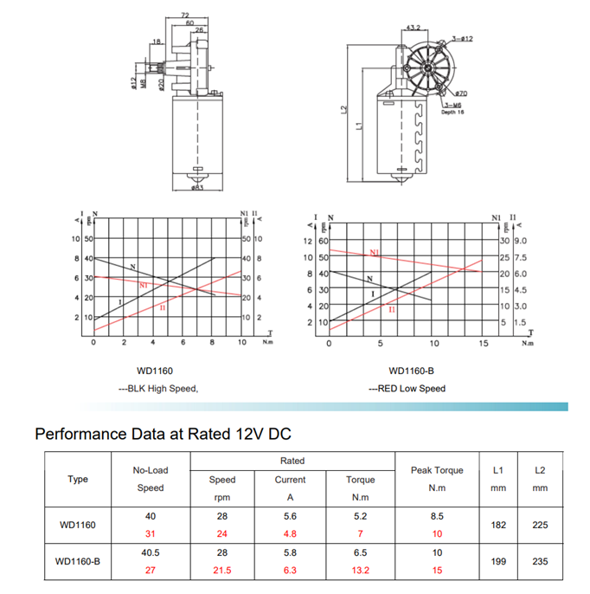

## 2.3 Internal Lightning of a car

2.3.1 Input or Sensors:

* This feature controls the brightness instrument panel lights. The instrument panel illumination control is next to the exterior lamp control. Press D + to brighten or D − to dim the lights.

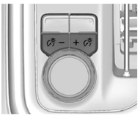

* The dome lamp controls are in the overhead console. The dome lamps will come on when doors are opened. ON/OFF: Press to turn the dome lamps on manually. Press again to turn the dome lamps off.

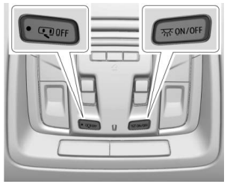

* There are reading lamps on the overhead console and over the rear seats. These lamps come on when any door is opened. Press to turn the dome lamps on manually. Press again to turn the dome lamps off.

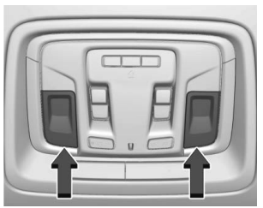

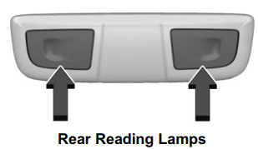

* User inputs:

Rotor switch**: A** **rotary switch** is a switch operated by rotation.

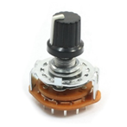

Push to on/off switch:

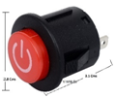

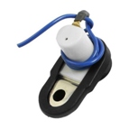

Sensor inputs:

Push Buttons**:** A **push-button** is a simple switch mechanism to control some aspect of a machine or a process. An automatic mechanism (i.e. a spring) returns the switch to its default position immediately afterwards, restoring the initial circuit condition.

|  |  |  |  |
| --- | --- | --- | --- |
| **Technical Specifications** | **Push Buttons** | **Rotor Switch** | **Push to on/off switch** |
| Voltage | 24v DC | 28v DC | 24v DC |
| Power Rating |  |  |  |
| Current Rating | MAX 50mA | 350mA | 50mA |
| Insulation Resistance | 100Mohm at 100v |  | 100Mohm at 100v |
| Operating Force | 2.55±0.69 N |  |  |
| Temperature range | -25 to +55°C | -25 to +55°C | -25 to+55°C |
| Angle of throw | - | 30degree | **-** |

2.3.2 Algorithm

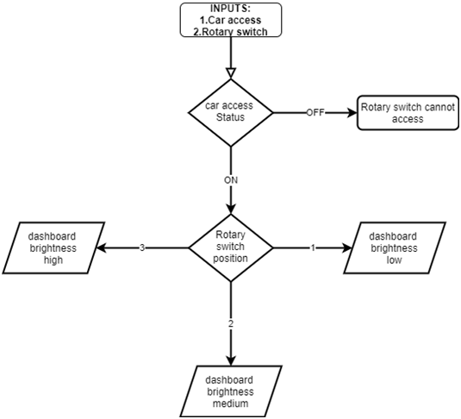

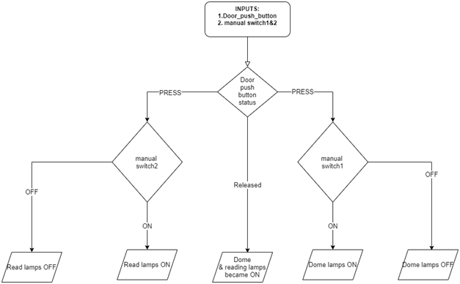

2.3.3 Output:

* Dome lights:

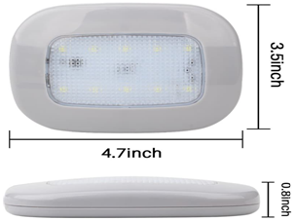

* Reading lights:

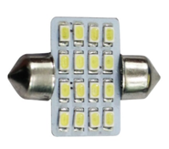

* LED Lights:

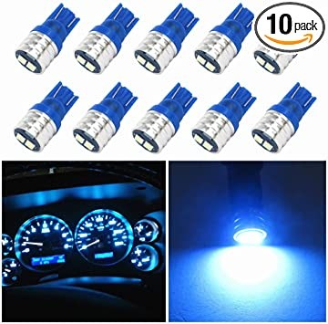

|  |  |  |  |
| --- | --- | --- | --- |
| **Technical Specifications** | **Dome lamp** | **Reading lamp** | **LED** |
| Voltage | 12v DC | 12v DC | 12vDC |
| Current | 0.2A | 0.2A | - |
| Power | 2.5W | 2.5W | 1W |
| Temperature range | -40c to 65c | -40c to 65c | - |

## 2.4 Seat Belt Module:

2.4.1 Input or Sensors:

* Power
* Driver Occupation detection by sensor mat
* reed sensor for buckle status

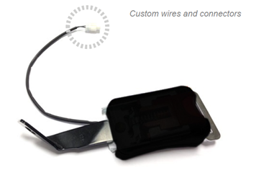

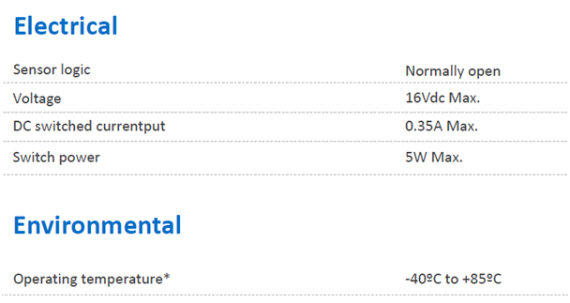

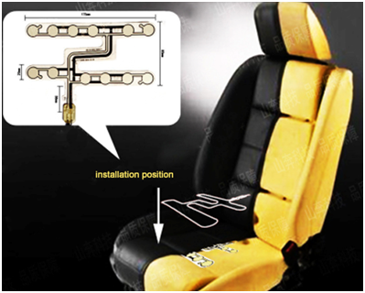

2.4.2 Algorithm

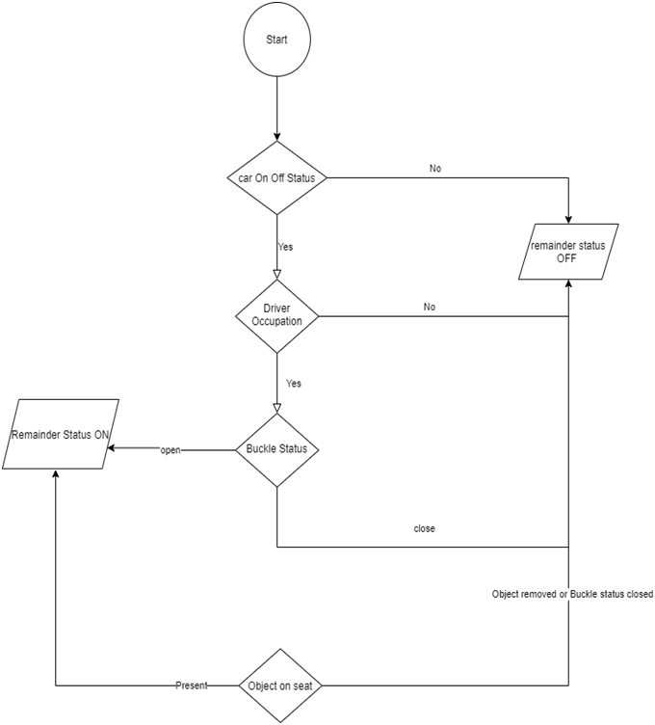

2.4.3 Output

* remainder light
* Chime

## 2.5 HVAC Module

2.5.1 Input or Sensors:

* User Interface

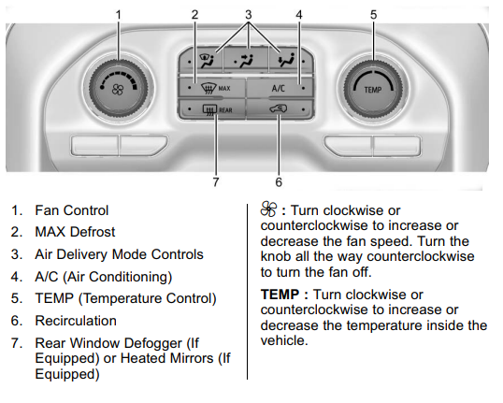

* V series Rotary switch (3 position)
* AVH switches

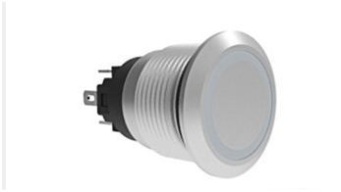

Temperature Sensors:

|  |  |  |  |  |  |
| --- | --- | --- | --- | --- | --- |
| SensorName | Optemp_range | Max_dissipation | Linearity | Op_current | Power |
| NTCLE203E3...SB0(NTC) | -55°C to +150 °C | 100mW | 25°C to 85°C | 2mA-5mA | 4V to5V |
| HEL 700 series (RTD) | -70°C to +260°C | <15mW | -40°C to125°C | 2mA | 4V to6V |
| LM 35(LM series) | -55°C to +150°C | Low self-heating | Full range | 10 mA | 4V to 5.5V |

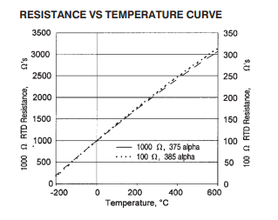

Humidity Sensor datasheets:

|  |  |  |  |
| --- | --- | --- | --- |
| Sensor Name | Optemp_range | Operating_voltage | Power_dissipation |
| HDC1008 | -20°C to 60 °C | 2.7 v to 5.5 v | 150 uW |
| HTU21D(F) | -40 to +125 °C | 3.8 v | 2.7 uW |

2.5.2 Algorithm:

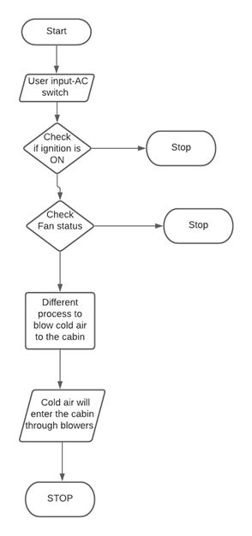

Fig: AC working

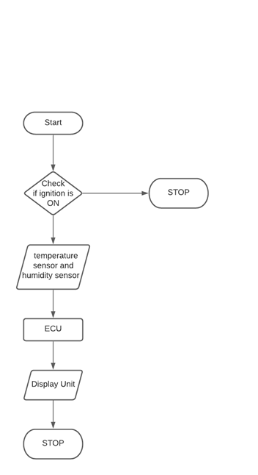

Fig: Calculation of Room temperature and humidity inside the cabin.

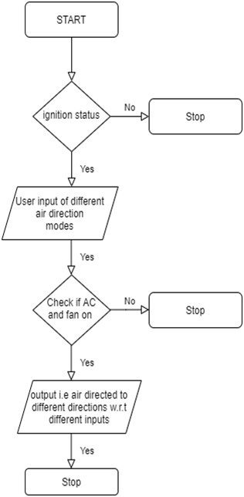

Fig: Algorithm to direct air from blowers in different directions.

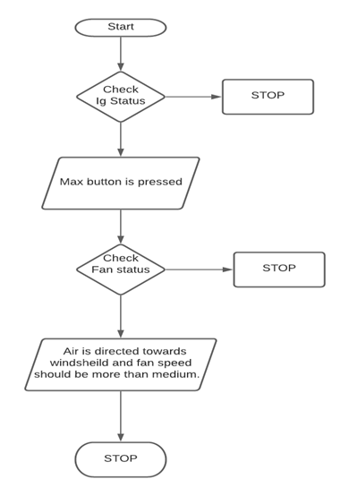

Fig: Algorithm to remove rear fog.

2.5.3 Output:

* The cooled air will reach the cabin through blowers.

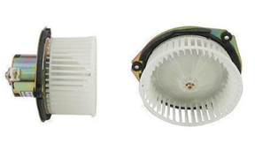

Fig: Blowers used to provide cold or hot air inside the cabin.

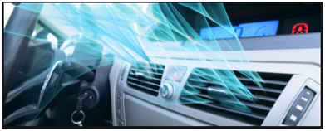

Fig: Blowers present in the dashboard

* The temperature and humidity of the car will be displayed in the dashboard.

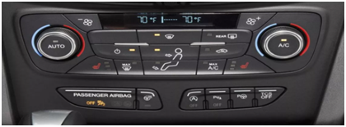

Fig: HVAC system present in the dashboard.

## 2.6 FEATURE:

The reference car used for detailed research and modelling is GMC Seirra 2020.

This document refers to some redefined features of GMC Seirra. The features are as follows:

2.6.1 Airbag Control System

The Airbag control system is a safety feature which works along with seat belt.

Airbag is a supplementary protection.

Definition:

* Accelerometer sensor is used to detect the crash. Here ADXL50 is used as

Crash sensor.

* Seat belt status is measured. The output of seat belt is taken as constant.

The airbag gets deployed whenever there is a front crash and driver is wearing the seat belt.

2.6.2 Wiper Control System

Wind screen wiper is essential for keeping the windscreen sufficient clean for driver’s visibility specifically for modern high-speed vehicles. The washer cleans the driver’s side of the windscreen whenever required.

Definition:

* Motor used is Wiper motor. (WD1160)
* Washer pump is used to spray the washer liquid. (CL508M12V)
* Rotary switch is used for different wiper modes.

Features:

* 4 different speeds of wiper system.
* Windshield washer.
* Mist mode.

2.6.3 Internal Lightning

Internal lightning is feature which illuminates the interior lights of a car based on different scenarios.

Definition:

* Push button is used as interface.
* Instrument panel brightness.
  + - 1. If access is off, instrument panel brightness is disabled.
      2. If access is on, instrument panel brightness is enabled and we decrease and increase the brightness according to the user.
* There are three modes of dome lamp and reading lamps described in this document:
  + - 1. If door is closed both reading lamp and dome lamp will be off.
      2. If door is open both reading lamp and dome is on irrespective of manual input.
      3. If door is in door mode condition, then it depends upon the manual input in the car.

2.6.4 Seat belt control module

Seat belt is one of the primary safety feature used in vehicle to avoid major injuries.

Definition:

* Seat Occupancy Membrane Pressure Sensor for car seat is used to detect the object present on the seat. Here pressure applied by the object is taken as input and equivalent resistance is given which is mapped to a certain voltage as output.
* Seat belt sensor used in this project works as a switch. If seat belt is buckled, then the sensor acts as a closed circuit and the data is sent to the ECU.

Feature:

* Any object present in the passenger seat is detected as a human being.

The reminder will be on, to make it off the object should be removed or the seat belt should be put.

2.6.5 HVAC module

Definition: This document covers only the AC part of the total HVAC system.

* Manual HVAC i.e. user inputs.
* Temperature sensor is used to sense the temperature of the cabin. (LM 35 series).
* Humidity sensor is used to capture the amount of humidity present in the cabin. (HEL 700 series)
* Rotary and AVH switch is used for user interface.

Features:

* 3 air direction modes- air towards feet; air towards windshield; air towards outlet. Any combination of them can be used.
* Rear fog remover.
* Recirculation.

## 2.7 SWOT:

2.7.1 SWOT Analysis for Airbag Systems

|  |  |
| --- | --- |
| Strength   * Airbags prevent injuries among drivers and passengers in the event of a crash. * Airbags is effective to fully inflated in a short amount of time. | Weakness   * Air bags do not replace the need for seat belts. Some people wearing no belt or only a lap belt have been hurt and killed by the deployment of the airbag. * Once the airbag is deployed it has to be replaced by the consumer, which costs about $500-$2000. |
| Opportunities   * The market for airbag has been growing at a higher pace than that of automotive market due to increasing awareness towards passenger safety. | Threats   * Active safety systems will overtake passive protection, such as airbags. These advanced systems can impose serious threats to airbag industry. |

Fig: SWOT analysis for Airbag

2.7.2 SWOT Analysis for Wiper Control System

|  |  |
| --- | --- |
| **Strengths:**   * **User friendly.** * **5 different modes of wipes.** * **Sufficiently removes rain water, snow, ice, washer liquid etc.** | **Weakness:**   * **Doesn’t have automatic operation.** * **No other means of control than the wiper lever.** |
| **Opportunities**   * It can be expanded to automated system   Like using rain sensor system operates automatic. | **Threats**   * **Motor failure** * **Wiper blade damages** |

Fig: SWOT Analysis for Wiper control system

2.7.3 SWOT analysis of Internal lightning of a car.

|  |  |
| --- | --- |
| **Strength**   * Innovation and user friendly. * Durable and long lasting. * Easily available in market. * Good referral relationships with architects, complementary vendors and local realtors | **Weakness**   * Not established in a market where a variety of interior design options exist. * Challenges of the seasonality of the business. * Competitors can offer similar products quickly |
| **Opportunities**   * Interior Lights can be used in any vehicles like in bus, trucks, train etc. * Interior lights can be used in home appliances to pleasing environment. | **Threat**   * Rising prices of materials and services * Designers being contracted up from the city * Changes in regulations can impact the business |

Fig: SWOT analysis for Internal lightning of a car.

2.7.4 SWOT Analysis for Seat belt control module

|  |  |
| --- | --- |
| **STRENGTHS**   * Safety of user * Helps in Airbag operations | **WEAKNESS**   * Detects object as user * Driver negligence |
| **OPPORTUNITIES**   * Negligence of seat belt remainder should restrict the speed of vehicle | **THREATS**   * Sensor malfunction * Hardware Malfunction |

Fig: SWOT analysis for seat belt control module.

2.4.5 SWOT Analysis for HVAC Module

|  |  |
| --- | --- |
| **STRENGTH**   * To provide comfort to the driver and passengers by maintaining the temperature inside the cabin. * Less cost than manual HVAC. | **WEAKNESS**   * The driver or the passengers need to provide the modes to control the climate inside the car. (i.e. it is manual not automatic) * More fuel consumption. |
| **OPPERTUNITIES**   * Large market size in India. * Temperature conditions in subcontinent regions. | **THREATS**   * Existence of strong competitor. |

Fig: SWOT analysis for HVAC module.

# 3.REQUIREMENTS:

## 3.1 HIGH LEVEL REQUIREMENTS:

|  |  |
| --- | --- |
| BCM_AB_HLR_1 | Detection of Crash |
| BCM_AB_HLR_2 | Deployment of airbag |
| BCM_WP_HLR_3 | Wiper ON and OFF |
| BCM_WP_HLR_4 | Wiper Mode Control |
| BCM_WP_HLR_5 | Single wipe and several wipes |
| BCM_WP_HLR_6 | Spray windshield washer fluid and Activate the wipers. |
| BCM_SB_HLR_7 | System should remind the user to wear the seat belt. |
| BCM_HVAC_HLR_8 | When the driver or passenger turn on the AC and fan switch, then cool air must enter the cabin of the car through blowers. The ignition should be switched on. |
| BCM_HVAC_HLR_9 | Fan rotary switch must control the speed of air entering the cabin. |
| BCM_HVAC_HLR_10 | The temperature rotary switch must control the temperature of the air entering the cabin. |

## 3.2 LOW LEVEL REQUIREMENTS:

|  |  |
| --- | --- |
| Requirements | Description |
| BCM_AB_LLR_1 | Seat Occupancy- Using Pressure Sensor |
| BCM_AB_LLR_2 | Seatbelt - Using Seatbelt Warning Module |
| BCM_AB_LLR_3 | Seatbelt Tighten - Tighten the seat belt |
| BCM_WP_LLR_4 | Rotary switch to start and select wiper Mode. |
| BCM_WP_LLR_5 | Push Button to turn on the washer fluid pump. |
| BCM_WP_LLR_6 | Control wiper motor speed for different speed. |
| BCM_SB_LLR_7 | Vehicle Power On/Off status. |
| BCM_SB_LLR_8 | User Occupation on Seat. |
| BCM_SB_LLR_9 | Seat Belt Buckled Status. |
| BCM_IL_LLR_10 | Dashboard brightness increase/decrease by rotary button. |
| BCM_IL_LLR_11 | Reading lamps are ON when Doors are open or by manual switch. |
| BCM_IL_LLR_12 | Dome lamps are ON when Doors are open or by manual switch. |
| BCM_HVAC_LLR_13 | If AC is switched ON and fan is not switched ON then the AC should not work. |
| BCM_HVAC_LLR_14 | The temperature sensor present below and above the cabin will monitor the temperature and its output is current, which is send to ECU that will convert the current into equivalent temperature. This value is displayed in the dashboard. |
| BCM_HVAC_LLR_15 | The humidity sensor present in the cabin will calculate the humidity and the result will be displayed in the dashboard via ECU. |
| BCM_HVAC_LLR_16 | When the recirculation switch is pressed then the cabin of the car must get cool at a faster rate. Here the fan speed must increase and the temperature of the air must decrease. |
| BCM_HVAC_LLR_17 | Air delivery mode buttons present in the dashboard must start and stop the respective blowers in the respective directions. |
| BCM_HVAC_LLR_18 | When Rear window defogger button is pressed, humid less air must enter the cabin and the fog created in the rear window must be removed. Here the fan speed should also increase. It must run when the engine is on. |
| BCM_HVAC_LLR_19 | When the max button is pressed, air is directed towards the windshield and the fan runs at a higher speed if not above a medium fan speed. |

# 

# 4.TEST PLAN:

## 4.1High Level Test Plan:

|  |  |  |  |  |  |
| --- | --- | --- | --- | --- | --- |
| ID | Description | Input | Expected Output | Actual Output | Test Type |
| BCM_SB_HLR_01 | Vehicle On/Off Status | Ignition On | Display Power On | Display Power On |  |
| BCM_SB_HLR_02 | Seat Buckle should be working | Fasten seat belt | It should get buckled in. | Gets buckled in. |  |
| BCM_SB_HLR_03 | Seat belt Reminder should not indicate. | Fastening of seat belt. | No output on the display to indicate. | No output on the display to indicate. |  |
| BCM_IL_HLR_04 | Interior lights like dome and reading lights become on and brightness of instrumental panel become brighten | Dome switch, reading switch to ON and rotary switch | Dome Lamp and Reading Lamp should ON and brightness increases/decreases | Dome Lamp and Reading Lamp should ON and brightness increases/decreases |  |
| BCM_HVAC_HLR_05 | The AC should work after the ignition is ON and the fan status is ON | User input; switching ON the AC and fan button | Cool air must blow in the cabin through blowers. | Cool air must blow in the cabin through blowers |  |

## 4.2 Low Level Test Plan:

|  |  |  |  |  |  |
| --- | --- | --- | --- | --- | --- |
| **Test id** | **Description** | **Expected i/p** | **Expected o/p** | **Actual o/p** | **Type of test** |
| BCM_IL_LT_1 | Dome Lamp is ON whenever door is open irrespective of manual inputs | Any one door open | Dome Lamp should ON | Dome Lamp ON | Requirement base |
| BCM_IL_LT_2 | Reading Lamp is ON whenever door is open irrespective of manual inputs | Any one door open | Reading Lamp should ON | Reading Lamp ON | Requirement base |
| BCM_IL_LT_3 | Dome Lamp is ON door is closed and manual switch is ON | Door should be closed and dome manual switch to ON | Dome Lamp should ON | Dome Lamp ON | Requirement base |
| BCM_IL_LT_4 | Reading Lamp is ON door is closed and manual switch is ON | Door should be closed and reading manual switch to ON | Reading Lamp should ON | Reading Lamp ON | Requirement base |
| BCM_IL_LT_5 | Dashboard LED is brightening according to rotary switch | Car Access enable and rotary switch position 1 | Low brightness | Low brightness | MCDC BASE |
| BCM_SB_LT_01 | Seat belt remainder should not indicate if seat is unoccupied | Passenger unbuckled | No indication | No indication |  |
| BCM_SB_LT_02 | Seat belt remainder should indicate if seat is occupied | Object Detected | Passenger Seat Belt Indication | Passenger Seat Belt Indication |  |
| BCM_SB_LT_03 | Seat belt remainder should stop indicating if object is removed. | Object Removed | No Indication | No Indication |  |
| BCM_SB_LT_04 | Seat belt remainder should stop indicating if Buckled | Buckled | No Indication | No Indication |  |
| BCM_SB_LT_05 | Vehicle status Off | Buckled or Unbuckled | No Indication | No Indication |  |

# 5.Design and Implementation:

# 

# 6.References:

Datasheet for rotary switches: <https://www.carlingtech.com/sites/default/files/documents/V-Series-Rotary_Details_%26_COS.pdf>

Datasheet for AVH switches: [https://www.carlingtech.com/sites/default/files/documents/av-avh- series_datasheet.pdf](https://www.carlingtech.com/sites/default/files/documents/av-avh-%20series_datasheet.pdf)

Datasheet for temperature sensors:

LM series: <https://www.ti.com/lit/ds/symlink/lm35.pdf>

NTCLE203E3...SB0(NTC) : <https://datasheet.octopart.com/NTCLE203E3272FB0-Vishay-datasheet-8822945.pdf>

HEL 700 series: <https://www.alldatasheet.com/datasheet-pdf/pdf/228376/HONEYWELL/HEL-700.html>

Datasheets for humidity sensors:

HDC1008: <https://www.ti.com/lit/ds/symlink/hdc1008.pdf>

HTU21D(F): <https://cdn-shop.adafruit.com/datasheets/1899_HTU21D.pdf>